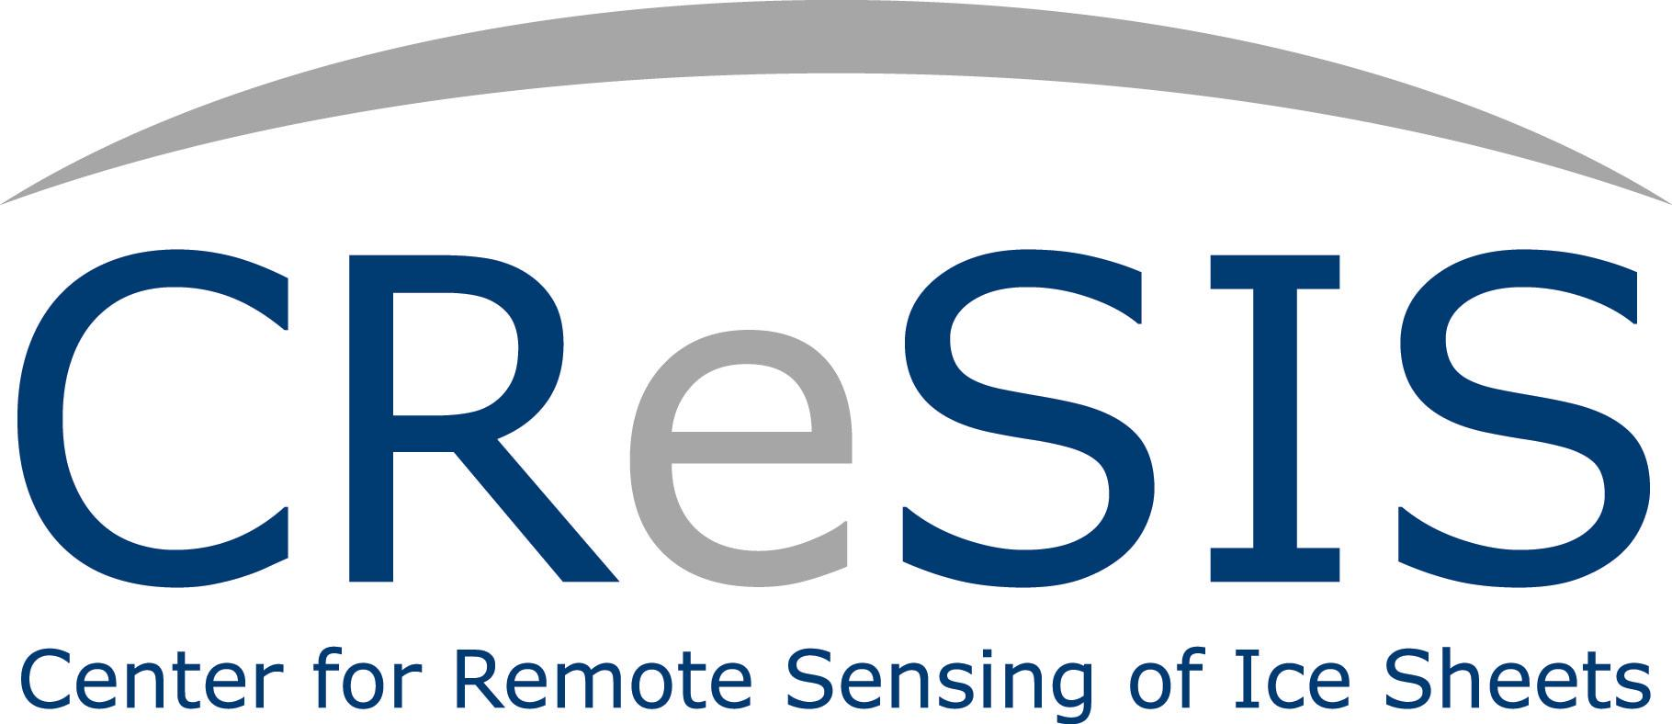

To: CReSIS Summer Middle School Researchers and Parents
From: Dr. Darnell Johnson, Program Coordinator
Date: May 14, 2013

Congratulations, your child has been chosen from a pool of thirty candidates applying for the CReSIS Middle School Program. Students are expected to report to room 232 in Dixon Hall on Monday, June 17, 2013 at 9:00am with at least one parent or guardian on the campus of Elizabeth City State University. Parents must arrange transportation to and from the campus on a daily basis.

We look forward to working with each student this summer. The schedule for the program is below. An optional open lab period will be available in 232 Dixon Hall each day from 9:00 am – 10am and 3pm – 4pm. Students can use the open lab periods to complete required assignments or prepare for the next day. Students will receive a stipend of $100.00 (after the completion of task sheet assignments) on the last day of the program.

Please call 335-3977 or email me at djohnson@mail.ecsu.edu should you have questions regarding this program.

 | 10am - noon | Noon – 1pm | 1pm – 3pm
All Students should report to 111 Lane Hall on the Campus of ECSU each day.
Mon. June 17 | Program Opening  Dr. Linda Hayden | Lunch Seminar:  Jerome Mitchell | Digital Camera Training  Jeff Wood
Tues. June 18 | PowerPoint Training Jeff Wood | Lunch Seminar:  Justin Deloatch | “FUN” Math  REU Math Team
Wed. June 19 | Climate Change  Cheri Hamilton | Lunch Seminar:  Polar Movie-Antarctica | “FUN” Math  REU Math Team
Thurs. June 20 | Climate Change  Cheri Hamilton | Lunch Seminar:  Polar Movie-Greenland | Aviation: Wind Tunnels  Orestes Gooden
Fri. June 21 | (7am-6 pm) VA Marine Science Center, Dolphin Watch and IMAX Theater
Mon. June 24 | Hydrology Training  Wanda Hathaway | Lunch Seminar:  Michael Jefferson | Hydrology Training
Tues. June 25 | Robotics with Legos  URE Math Team | Lunch Seminar:  Orestes Gooden | Robotics with Legos  URE Math Team
Wed. June 26 | GPS/GIS Training At “ECSU” Je’aime Powell
Thurs. June 27 | Virginia Air & Space Center - Electricity |  | Open Computer Lab
Fri. July 28 | Open Lab/Task Sheets Due | Closing Program and Luncheon

Program Staff
Principal Investigator: Dr. Linda Hayden, Math, Science and Technology/Associate Dean
Program Coordinators: Dr. Darnell Johnson, CReSIS Education Coordinator
Mrs. Wanda Hathaway, Science Instructor, Pasquotank County, NC
Power Point Trainer: Mr. Jeff Wood, CERSER Webmaster
Camera Trainer: Mr. Jeff Wood, CERSER Webmaster
GIS/GPS Trainer: Mr. Je’aime Powell, CERSER Lab Manager
Climate Change Trainer: Mrs. Cheri Hamilton, CReSIS Outreach Coordinator
Hydrology Trainer: Mrs. Wanda Hathaway
Robotics Facilitator: REU Math Team
Student Assistants REU Math Team
Administrative Assistants: Mr. Joal Hathaway, Mrs. Marisol Denny, & Mr. Kevin Jones,
CERSER

Seminar Guest Speakers
Dr. Malcolm LeCompte, Retired ECSU Professor, Antarctic Temperature Mapping
ECSU Undergraduate & Graduate STEM Majors
Mr. Orestes Gooden, Assistant Professor for Aviation Science
Mr. Jerome Mitchell, PhD Candidate, Indiana University

